> summary(ER_Final_Data$`stock return`)

Min. 1st Qu. Median Mean 3rd Qu. Max.

0.03757 0.20654 0.42183 0.44720 0.67780 1.00000

> summary(ER_Final_Data$`Economic Policy Uncertainty Index`)

Min. 1st Qu. Median Mean 3rd Qu. Max.

78.00 79.00 83.00 82.87 87.00 87.00

> summary(ER_Final_Data$`Investor Sentiment (CCI)`)

Min. 1st Qu. Median Mean 3rd Qu. Max.

1.850 1.930 2.010 2.007 2.080 2.130

> summary(ER_Final_Data$CPI)

Min. 1st Qu. Median Mean 3rd Qu. Max.

81.60 89.40 99.80 98.96 108.90 114.80

> summary(ER_Final_Data$non_risk)

Min. 1st Qu. Median Mean 3rd Qu. Max.

21.00 25.00 28.00 28.24 31.00 35.00

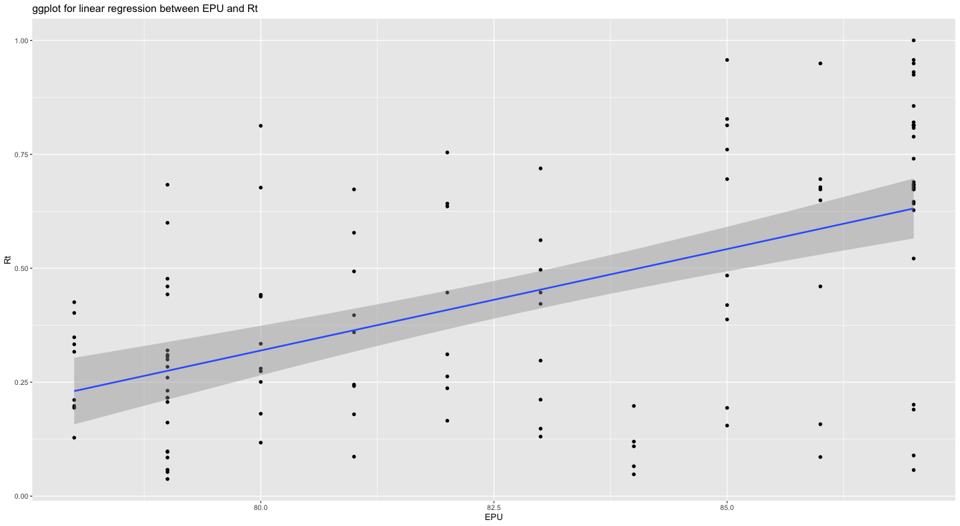

As the plot indicates, there is a slope that have a upward direction from lower left corner to upper right top. The range of Rt is between 0 and 1. The range of EPU is roughly from 75 to 90. Dots are scattered at an even level instead of a clustered type in the plot. Based on the regression result, the coefficient of EPU is 0.042667, it means that increase in one unit of EPU will result in 0.042667 increase in Rt. Thus, Rt and EPU have a positive correlation in this analysis.

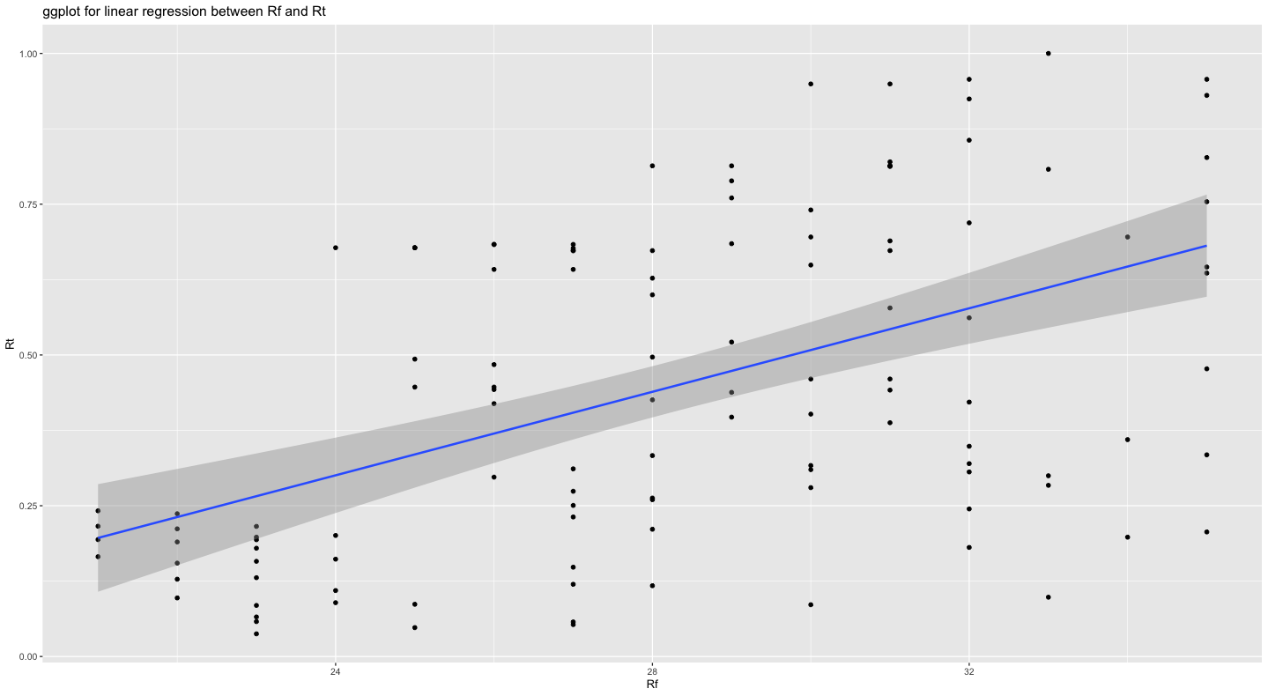

As the plot indicates, there is a slope that have a upward direction from lower left corner to upper right top. The range of Rt is between 0 and 1. The range of Rf is roughly from 20 to 36. Dots are scattered around the middle and right side of the plot. Based on the regression result, the coefficient of EPU is 0.032966, it means that increase in one unit of EPU will result in 0.032966 increase in Rt. Thus, Rt and Rf have a positive correlation in this analysis.